Claim History

Exercise 1: Configuration

Configure ClaimCenter to meet the following customer requirement from Acme Insurance.

**Requirement: Generate a claim history record**

Acme Insurance wants to track in its claim history a record of changes to the “Salvage Status” field.

1. Modify ClaimCenter such that any change to this field results in the creation of a claim history record. You may use an existing history type such as “Data change”. It is also possible to create a custom history type.
2. The ClaimCenter implementation team has provided additional notes:
   1. Place the code into the Claim Pre-Update rule set category, so that the history record will be created as soon as the claim is saved.
   2. The rule name should use the code "CPU00102" as a prefix.
   3. The history record description should include both the old and the new field values, as seen by the end-user.

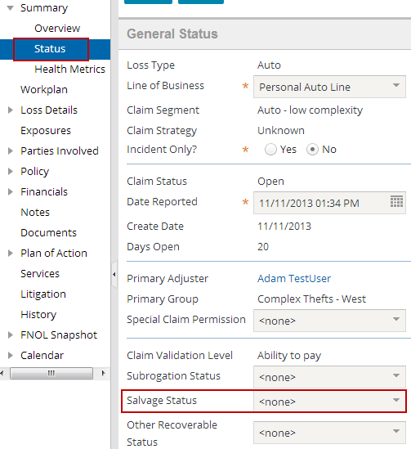

1. Test your work by going to an auto claim and changing the Salvage Status (found on the Claim Status menu link.) Your results should look like this in the History screen:

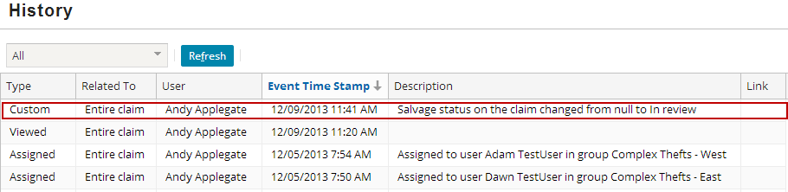

1. BONUS: *Complete this step only if your instructor tells you to do so.*

Note that the Type column shows “Custom” rather than “Data change”. Why do you think that is? Edit the pcf to make the history show the proper custom history type name if the history record is custom. Hint: The existing “Type” cell will need to be disabled and a new widget of type “cell” added to handle this configuration.

